Using  **tidycensus** package in R

Getting the following error when loading package after installation:

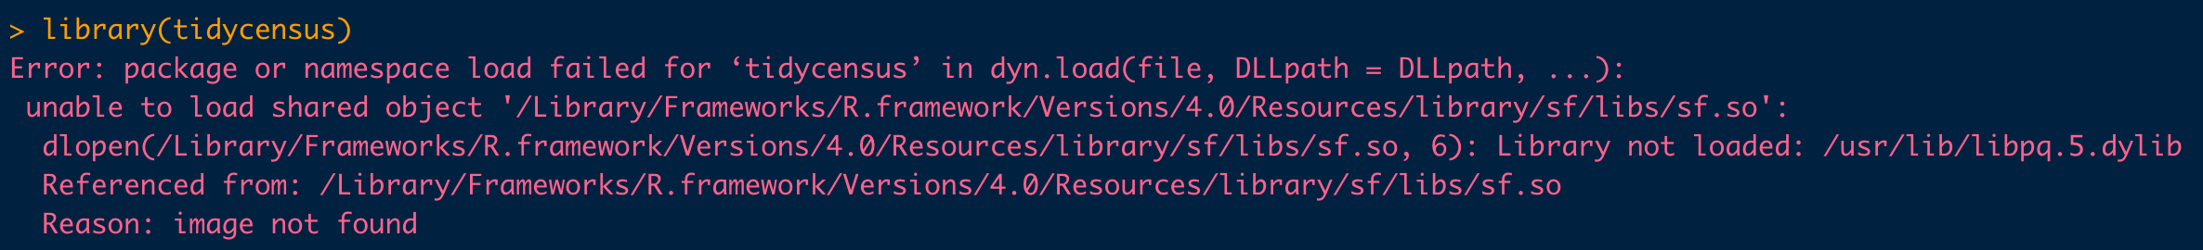

Fix ( <https://github.com/walkerke/tidycensus/issues/260)-->> this might take some time!

1. [terminal] brew install gdal (might need to install or updated Homebrew
2. [terminal] brew install pkg-config
3. [R] library(devtools)
4. [R] install.packages("rgdal", configure.args = c("--with-proj-lib=/usr/local/lib/", "--with-proj-include=/usr/local/include/"))
5. [R] install.packages("sf", configure.args="--with-gdal-config=/usr/local/gdal-3.4.1/bin/gdal-config --with-geos-config=/usr/local/bin/geos-config")
6. Restart R and re-load packages **tidycensus** and **tidyverse**

**Package vignette:**

<https://walker-data.com/tidycensus/index.html>

<https://walker-data.com/census-r/index.html>

* Spatial data available in tidy format and so we can use **ggplot2 package** to make maps
* ACS margins of error --> need to read more about this!
* Search for variables directly through R instead of looking at tables at <https://api.census.gov/data.html>

* <https://www.census.gov/programs-surveys/acs/guidance/estimates.html>
* <https://www.census.gov/data/developers/data-sets.html>

Request API Key to access data here --> <https://api.census.gov/data/key_signup.html>

Other error messages that might come up🡪 just need to reload or restart session

